**Spike:** 19

**Title:** Collisions

**Author:** Ford Killeen, 9731822

**Goals / deliverables:**

*Goals this spike aims to achieve:*

* Get collisions detecting between two objects
* Change material of actor when it is colliding

*Deliverables required:*

* Proof of UE4 collisions and material changing
* Spike report

**Technologies, Tools, and Resources used:**

The following is required to complete this spike:

* Unreal Engine 4 (ver. 4.13.2)
* Online UE4 material and guides

**Tasks undertaken:**

The list below details the steps taken to complete this spike.

* The first thing I did was investigate the use of the collision events already within the Unreal Engine.
* I then opened up the FirstPersonCharacter blueprint and in the Event Graph added the Hit and ActorBeginOverlap event nodes.
* The first thing that I did was then add the Set Material node so that on a collision the gun and arms of the character would change to red.
* I then needed to work out how to make the other colliding object change material as well. This was achieved by using the GetComponentByClass node to get the Mesh Component of the OtherActor value, which was then the target of the second Set Material node.

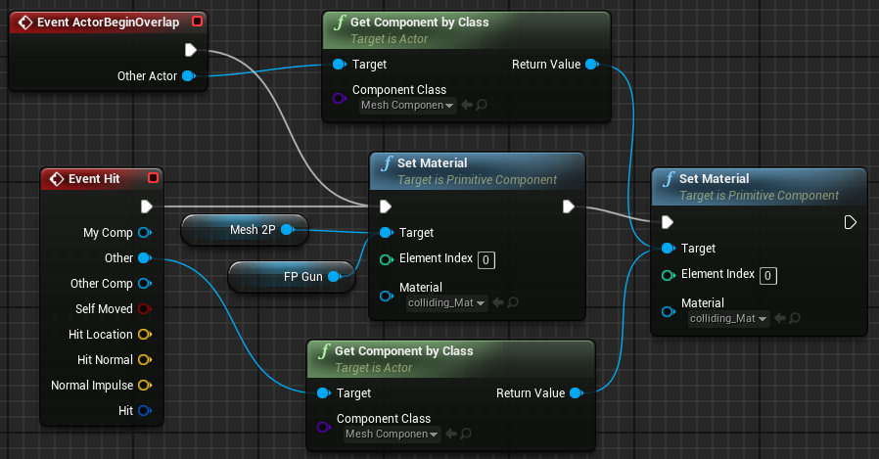

* I used the ActorEndOverlap event to try and change the material back to the non-colliding material, but this was happening too quickly or not at all if the collision type was a hit and not an overlap. I then decided to use the Tick event with a Delay node of 1 second to change the materials back to standard if the IsOverlappingActor node returned false.

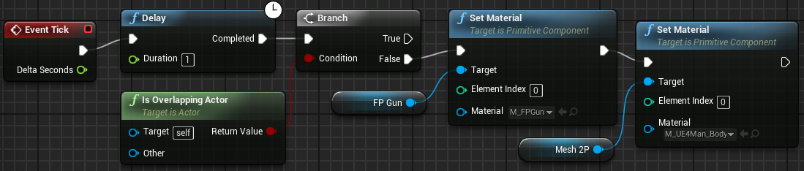

* I opened up my Car_Blueprint and Cube_Blueprints to ensure the materials were set back to normal after a collision had ended.

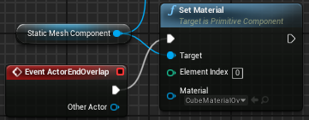

* I then tested this with different cubes and collisions between the character, cubes, car and projectiles. Images below as proof of material changes on collisions.

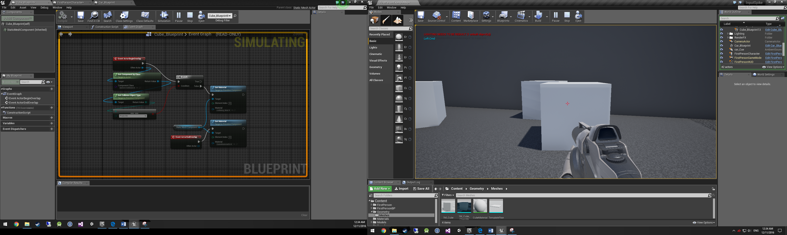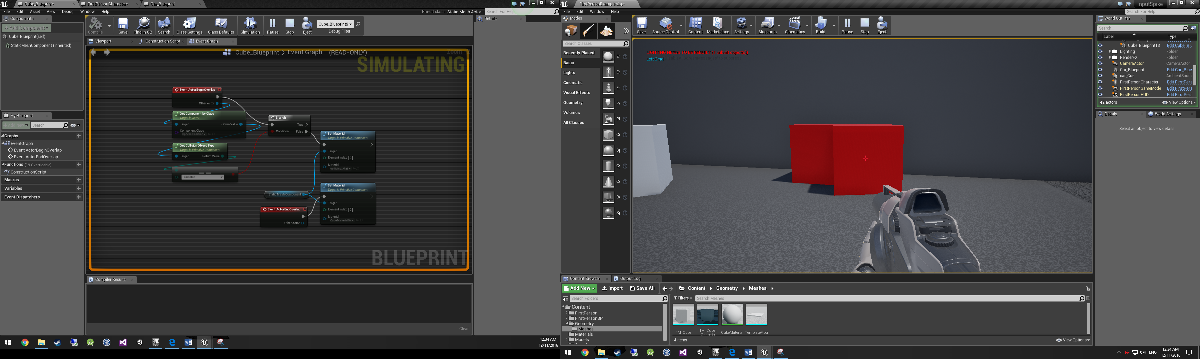

*Boxes colliding*

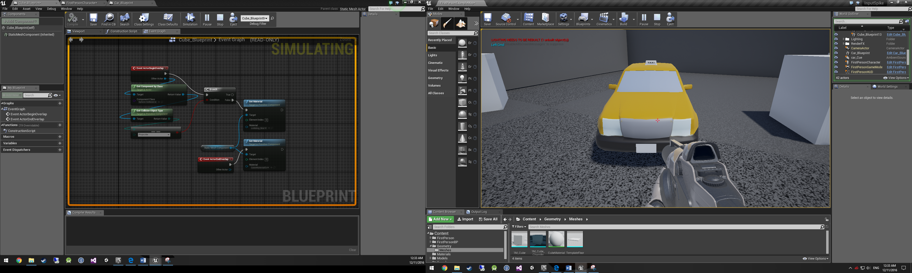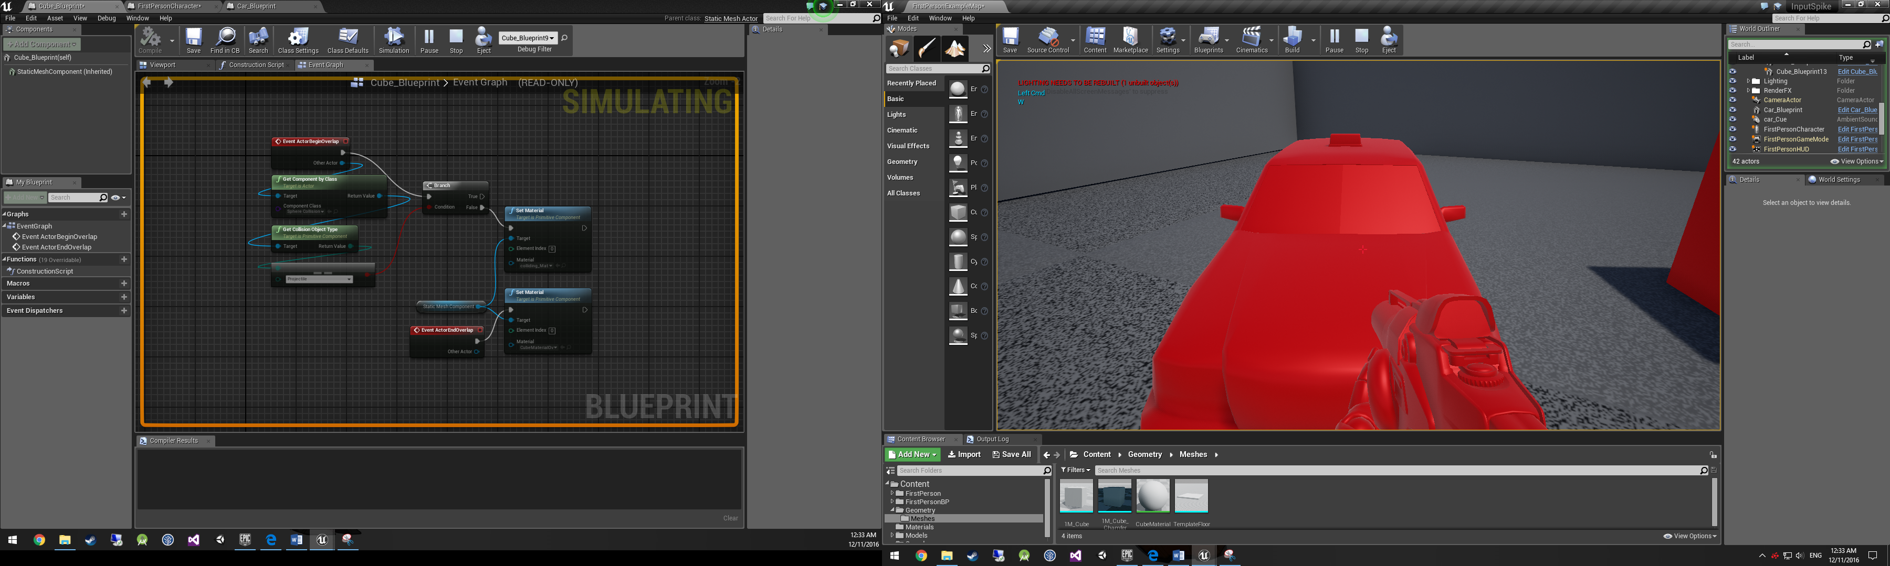

*Player and Car collision*

**What we found out:**

By completing this spike we found out how to add collisions to actors within the Unreal Engine and how to detect collisions and handle their events. Collisions are one of the most important features in most game genres as they may be collisions between projectiles, weapons, players, static objects and much, much more. Therefore a game developers understanding of collisions, how they work and how to use them is a very important skill to have.

**Issues:**

There were not a lot of issues with completing this spike but some of the bigger ones are listed below.

* The IsOverlappingActor node didn’t seem to be working correctly and only ever returned false. I couldn’t work out why, as I wanted to use this for my cube blueprint but ended up sticking to only the begin and end overlap event nodes.
* I wasn’t aware at first that I needed to enable the *Generate Hit Events* and *Generate Overlap Events* under the Collision section of the blueprint mesh component.